Project Name

Description 2

Architecture 3

Project Structure 4

Release Updates 5

Functions 6

Stored Procedure 7

APIs 8

Exceptions 10

# Description

Description about the project.

Service Run Process

1. Step 1
2. Step 2
3. Step 3
4. Step 4

# Architecture

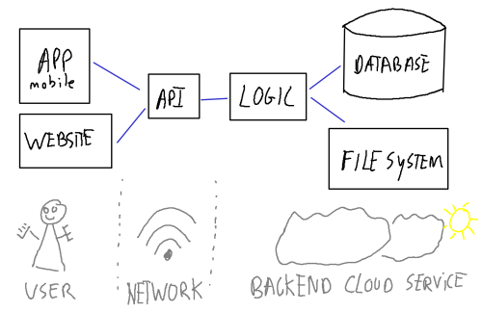

# Project Structure

Root Folder – Folder Name

* **main.py** – Main function – start function.
* **Config.py** – Service configuration parameters.
* **db_execute.py –** Execute Aurora/SQL server query/sp.
* **Sub Folder**
  + **__init__.py –** python package declares.
  + **main.py** - Main package function.

# Release Updates

**Version 1.0**

1. list of updates in this release.

# Functions

**Function Title**:

Function descriptions.

def my_function(event, context):

    '''

    Args:

        event:  dict str - JSON events data.

        context: dict str - JSON context data.

    Returns:

        None.

    '''

# Stored Procedure

|  |
| --- |
| **Sp_Stored_Procedure_Name** : Aurora SP  stored procedure details. |
| SP Parameters (as a tuple):   * param1::string * param2::integer * param3::datetime   Return:   * tuple – SQL row result |

# APIs





# Exceptions

How the project handle exception.